Assignment 1

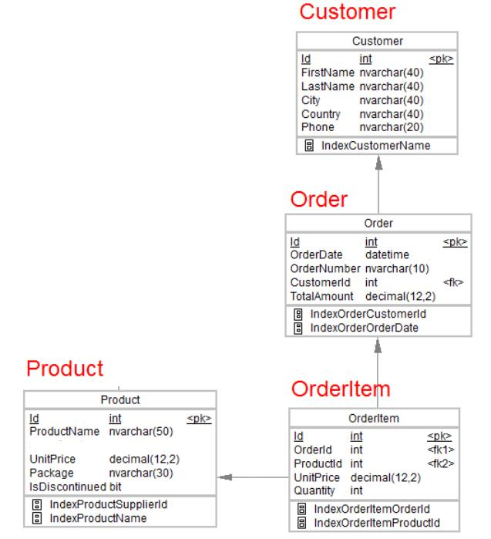

# 1.Desgin the above database with following table by applying Primary key and Foreign key

--1

create table Customer( id int primary key,

FirstName nvarchar(40),

LastName nvarchar(40),

City nvarchar(40),

Country nvarchar(40),

Phone nvarchar(20)

);

create table Orders(

id int primary key,

OrderDate datetime,

OrderNUmber nvarchar(10),

Customerid int FOREIGN KEY REFERENCES Customer(id),

TotalAmount decimal(12,2));

create table OrderItem(

id int primary key,

Orderid int FOREIGN KEY REFERENCES Orders(id),

Productid int FOREIGN KEY REFERENCES Product(id),

UnitPrice decimal(12,2),

Quantity int

);

create table Product(id int primary key,

ProductName nvarchar(50),

UnitPrice decimal(12,2),

Package nvarchar(30),

isDiscontinued bit);

# 2.Insert Records in all tables

--2

insert into Customer( id,FirstName,LastName,City,Country,Phone )

values (1,'ABC','DEF','City1','Country1','1010101010'),

(2,'prya','addc','City2','Country1','1010123456'),

(3,'ramesh','dcdcd','City1','Country1','1098765412'),

(4,'suresh','cdcdc','City3','Country1','9999999999'),

(5,'lakan','dcds','City6','Country1','188888888'),

(6,'sheetal','Ddcdc','City3','Country1','1777777770')

;

insert into orders values(1,'2000-12-12','101',1,123.23),

(2,'2001-12-1','101',2,123.23),

(3,'2002-1-1','101',3,123.23),

(4,'2003-9-12','101',4,123.23)

,(5,'2004-12-12','101',5,123.23),

(6,'2005-12-12','101',6,123.23);

insert into Product values(1,'pot',10.2,'package1',1),

(2,'vas',12.323,'package2',1);

insert into OrderItem values(1,1,2,12.323,10),

(2,2,2,12.323,10),

(3,3,2,12.323,10),

(4,4,2,12.323,10),

(5,5,2,12.323,10),

(6,6,2,12.323,10);

# 3.In Customer table FirstName Attribute should not accept null value

--3

alter table Customer alter column Firstname nvarchar(40) not null;

# 4.In Order table OrderDate should not accept null value

--4

alter table Orders alter column OrderDate datetime not null;

# 5.Display all customer details

--5

select * from Customer;

# 6.Write a query to display Country whose name starts with A or I

--6 Insert to add relevant data

insert into Customer(id,FirstName,LastName,City,Country,Phone )

values (7,'ABC','DEF','City1','America','1010101010'),

(8,'ABC','DEF','City1','India','1010101010');

select Country from Customer where Country like 'A%' or Country like 'I%';

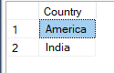

# 7. Write a query to display whose name of customer whose third character is i

--7 Insert to add relevant data

insert into Customer( id,FirstName,LastName,City,Country,Phone )

values (9,'priya','addc','City2','Country1','1010123456');

select * from Customer where FirstName like '__i%';

